**User Manual**

Most of our code is here. Including scratches and releases: https://github.com/AbhinavA10?tab=repositories

Some other earlier scratches, and one release are here: https://github.com/MattM7?tab=repositories

There are also some other failed scratches that are only in groupwork. We didn’t put them in github because we did not want to have failed scratches there.

Location of the game:

The most stable release can be found here: OS-AgraMeade → Releases → OS-Juggernoid-STABLE

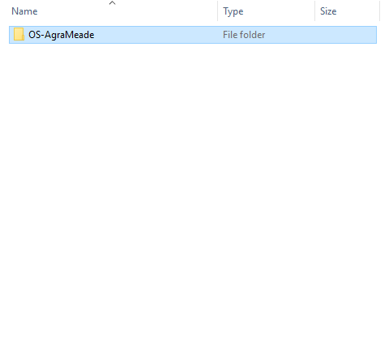

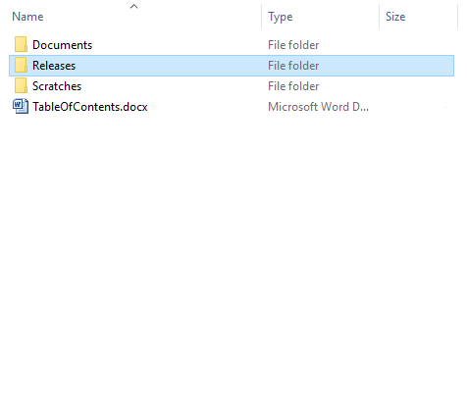

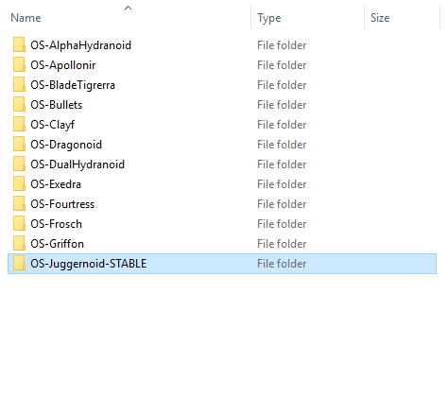

Controls:

Use “WAD” or the Arrow Keys to control the player’s movement. You can sprint by moving in the direction you would like to, and holding “SHIFT”

Using “Space” you can shoot bullets. Bullets can destroy certain tiles, such as the bushes, and will kill enemies.

Press “L” to turn the lighting effects on and off and “B” to turn the Box2D Debug renderer on and off.

Object of the game:

Avoid the flowers (it is actually a spike), and the bullets shot by enemies. Don’t forget to eliminate the enemies.